Lithuania ARU check & battery/SD card swap
Date: Between June 11 – 13, 2025
Equipment needs check: 12 sites (12 AudioMoth & 5 SongMini)
Required tools: microSD cards (12 + 2 backup), batteries (3 * 12 + 4 * 5 = 55), AudioMoth Chime app, site map, paper bags, pen, ziplock bags, zip ties, scissors and tapes
SongMini
1. Open the lid and switch the white toggle to “OFF”.  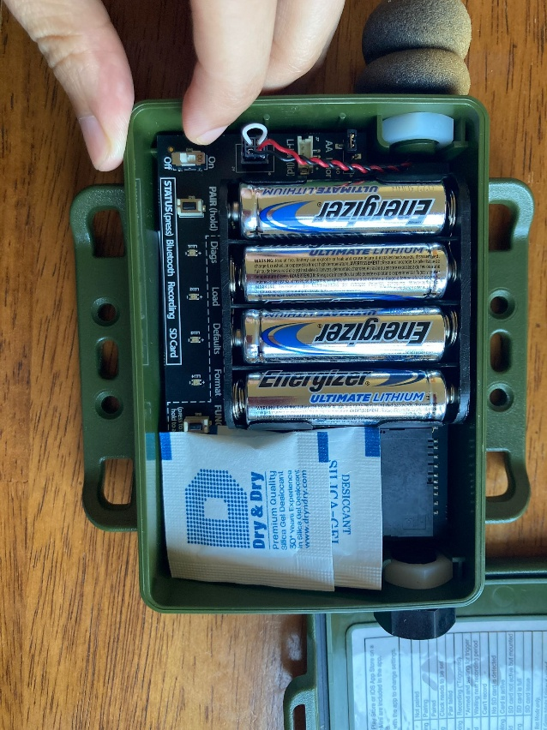 | 2. Replace batteries quickly (within 5 minutes to avoid clock reset).  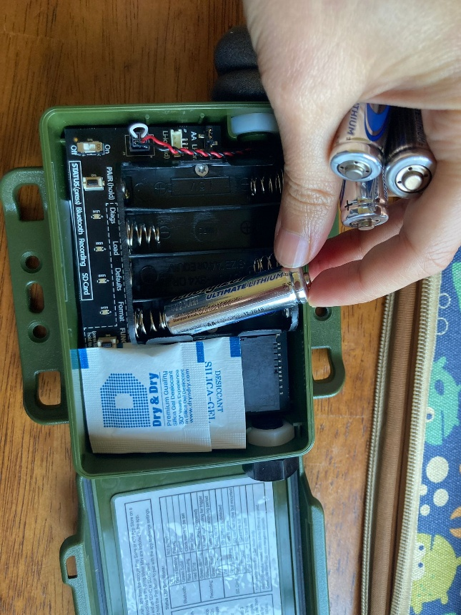
3. Switch the white toggle to “ON”. The Load and Defaults LEDs should both light up green.  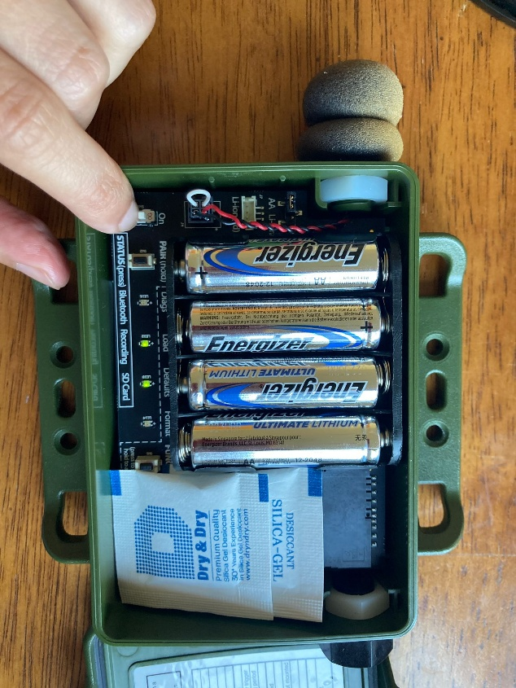 | 4. Close the lid and secure the unit. Check completed  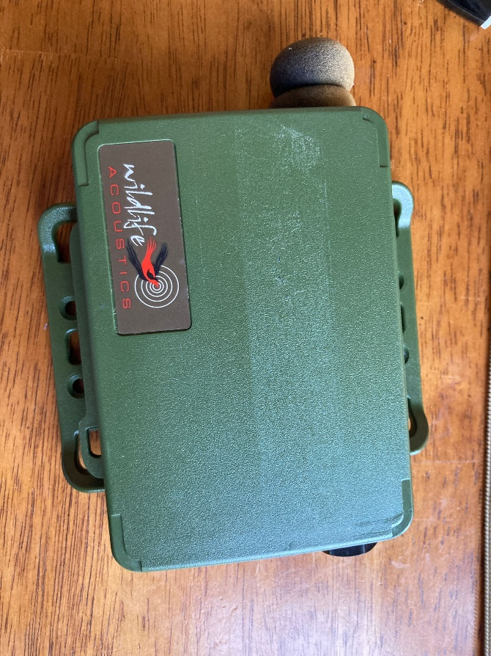
AudioMoth
1. Remove unit from its bag, check LED light status, and switch the white toggle to “USB/OFF”.  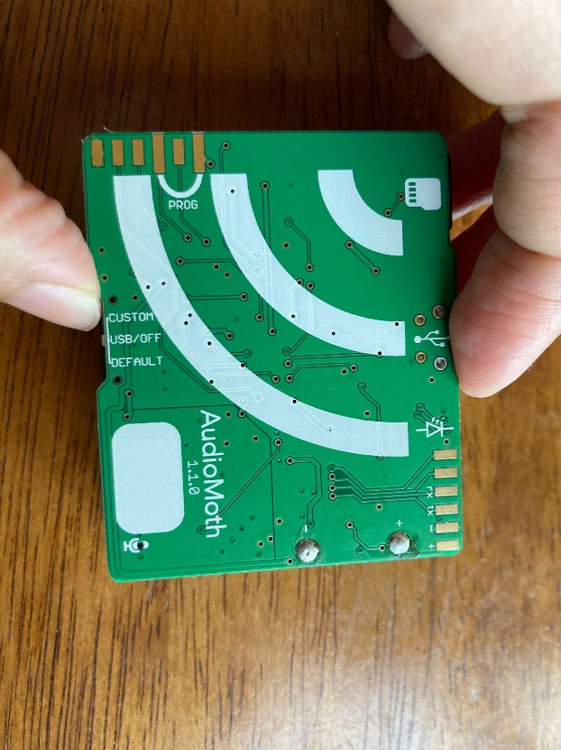 | 2. Remove and replace batteries.  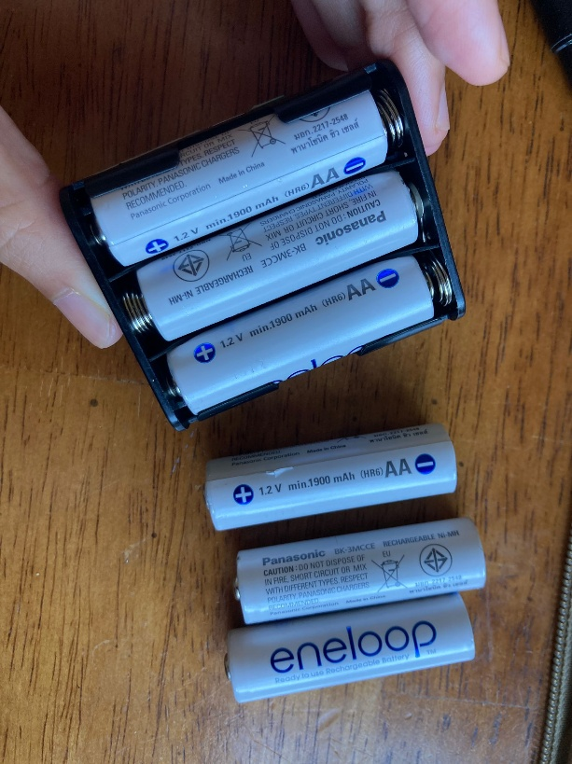
3. Remove the old microSD card and insert a new one.  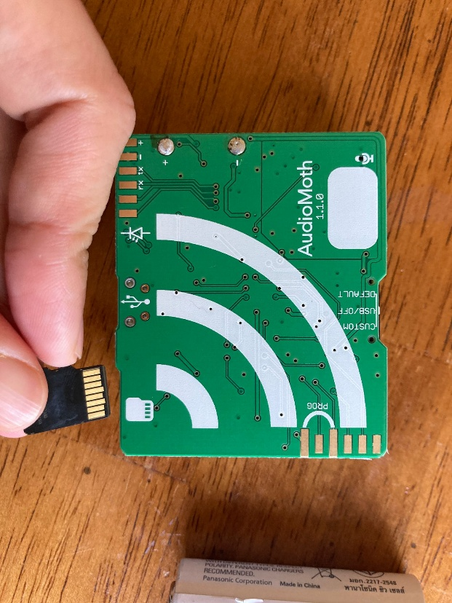 | 4. Place the old microSD card in a paper bag. Seal and label the bag with:  - Date (yyyy-mm-dd) and time (24 hours)  - Site  - LED light status when arriving the site  - Old SD card number  - New SD card number  - Your name  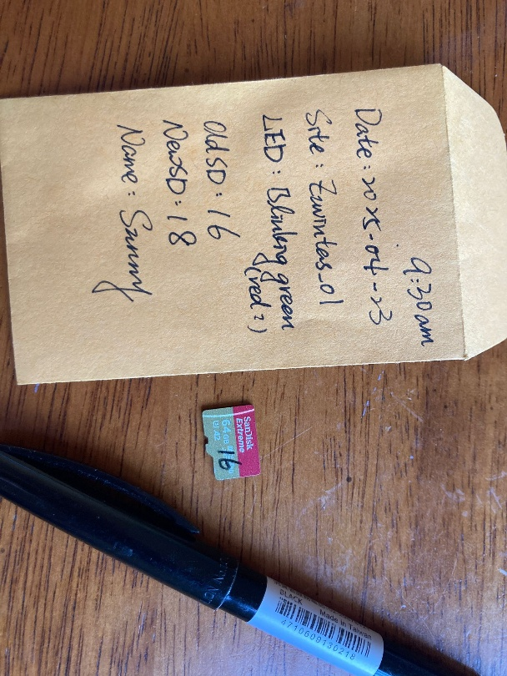
5. Switch the white toggle to “CUSTOM”. The LED should blink green with stable red.  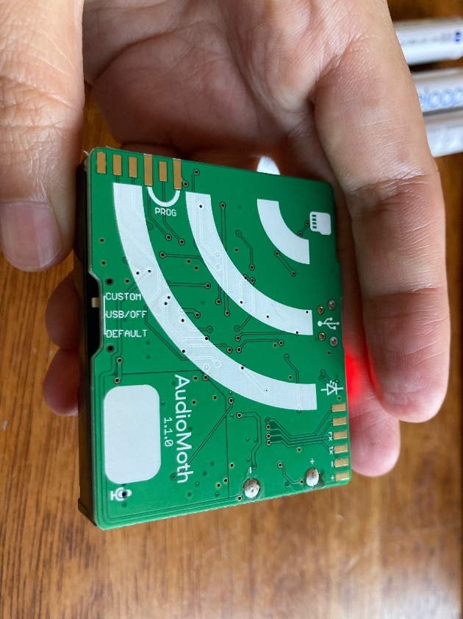 | 6. Play the Chime using the AudioMoth app to synchronize time. The red LED should turn off after successful calibration.  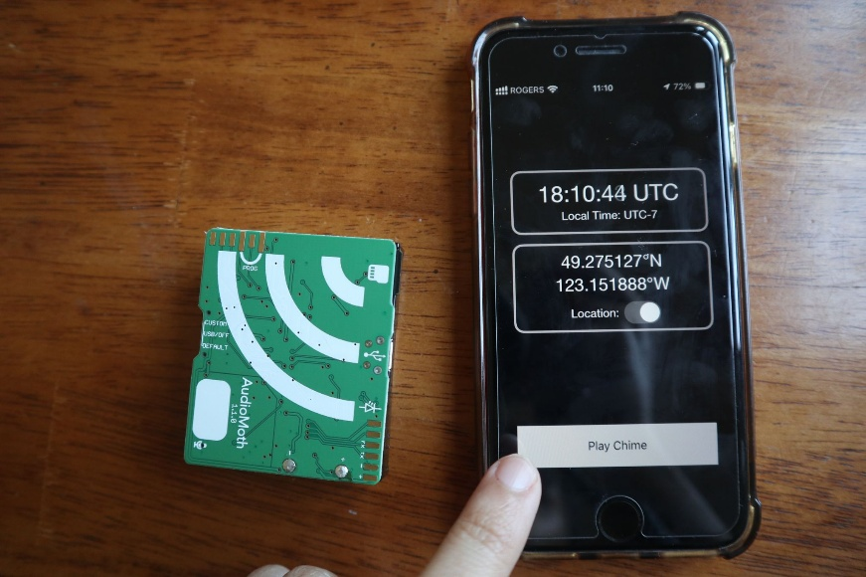
7. Secure the unit back into the bag and onto the tree or mounting location. Be careful that the elastic band is not covering the microphone. Check completed.

Note: Keep the 12 paper bags with the micro SD cards. Sunny will come picking them up in July! Thank you so much!

